# DISPLAY RULES AND REGULATIONS:

The following rules and guidelines specify what an exhibitor can and cannot do with their booth space. These rules and guidelines are based on the physical characteristics of the exhibit hall, the intent to be equally fair to all exhibitors, and the safety of all concerned. **Please review these rules and plan your display accordingly as variances will not be granted prior to the Show or on-site.**

# DEMONSTRATION AREAS:

Demonstration areas must be confined within the exhibit space so as not to interfere with any traffic in the aisles. Exhibitors must contract sufficient space to be able to comply with this rule.

When large crowds gather to watch a demonstration and interfere with the flow of traffic down the aisles or create excessive crowds at neighboring booths, it is an infringement on the rights of other exhibitors. Aisles may not be obstructed at any time.

# DEMONSTRATION EQUIPMENT:

Equipment, product, or machinery, when displayed to demonstrate or simulate industrial application, are exempt from the foregoing height limits, but are restricted only by ceiling height, as well as building and safety codes.

# EXPOSED AREAS MUST BE FINISHED:

All backwalls, sidewalls or any other exposed areas of the display must be draped or finished surfaces. No graphics, logos, or print facing into another booth is allowed. Any company advertisement or promotion must face into the aisle.

In-line and peninsula booths must have a finished back wall covering the back of the booth. See-through back walls or displays which do not cover the back wall completely will not be allowed.

Please note that ***ALL FIRE HOSE CABINETS MUST BE KEPT VISIBLE AND CLEAR.***

After 5pm on Monday, March 31st any part of a booth with unfinished side or back walls will be draped by Show Management at the expense of the exhibitor.

# GRAPHICS ON NEIGHBORS' SIDE:

The backside of walls - the common border facing a neighboring booth - must be clear of copy, logos, or other graphics, so as not to be an eyesore to neighboring exhibitors.

# HEIGHT LIMITATIONS:

INTERPHEX follows the cubic content rule, which allows exhibitors to make maximum use of their booth space. Under the cubic content rule, exhibitors may build up to the front of their booths, and up to the maximum allowable height according to booth type as indicated below.

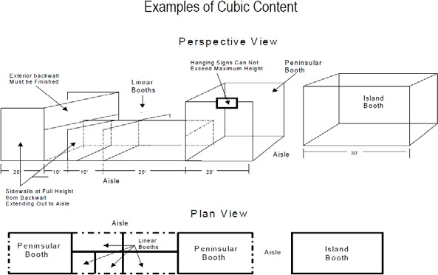

# HEIGHT LIMITATIONS:

## The following maximum height limits will be strictly enforced. No height variances will be granted prior to or on site at the show. Please plan your booth display and sign structures accordingly.

**• In-Line (standard) booth -**Bounded by 1 or 2 aisles- **10’ HEIGHT LIMITATION**

**• Peninsula booth (must be 400sqft or larger)-**Bounded by 3 aisles- **16’ HEIGHT LIMITATION**

**• Island booth -Bounded by 4 aisles (must be 400sqft or larger)- 20’ HEIGHT LIMITATION**

PLEASE NOTE: Nothing will be permitted above these maximum heights, including signs, banners, truss structures, lighting, and display materials

# INSPECTION DEADLINE:

Any booth not occupied by 12:00 PM on Monday, March 31st will be presumed abandoned. If there is freight in the booth and Show Management believes the exhibitor will be late, then FREEMAN will set up the display as best they can with the information available. If there is no freight in the booth and/or Show Management believes the exhibitor will not participate in the show, the booth will be reassigned. **Exhibitors arriving after this time will be given space available and may incur additional costs.**

All exhibits must be completely set by 5pm on Monday, March 31st. Although exhibitors may fine tune their booth before Show opening, no shipment will be accepted after Monday, March 31st at 5pm. No shipment, equipment, or material may be brought onto the show floor during show hours.